

CSE471 : System Analysis and Design
Lab Assignment on Figma

Project Title : Project Title Here
Group Number : 07

Submitted by : Shees Mohammad Hossain Saud
Student ID : 20101234
Section: 12

Date : 03/03/2026

Instruction:
- You have to design the interfaces of any two of your assigned features [according to the submitted requirement analysis] of your project using Figma. All members should work on the same project.
- The designed interfaces can not be duplicated among group members.
- Common interfaces like login form, sign up form, forget password, profile management page must be avoided.
- You can check out this manual: Lab 03 : Figma Manual.docx
- Sample figma file link:
https://www.figma.com/design/yiKMQ4K5v3LF3DMYGbd1SS/Figma-basics?node-id=601-11&t=3xuNTZJ4iouU77qL-1
Sample Prototype link:
https://www.figma.com/proto/yiKMQ4K5v3LF3DMYGbd1SS/Figma-basics?node-id=601-11&t=3xuNTZJ4iouU77qL-1

Feature- 01:Text based issue Submission

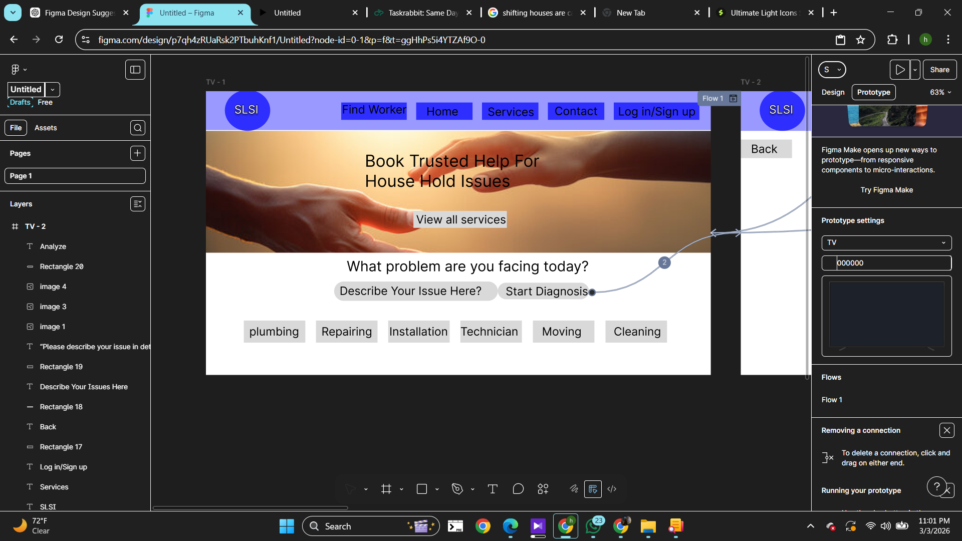
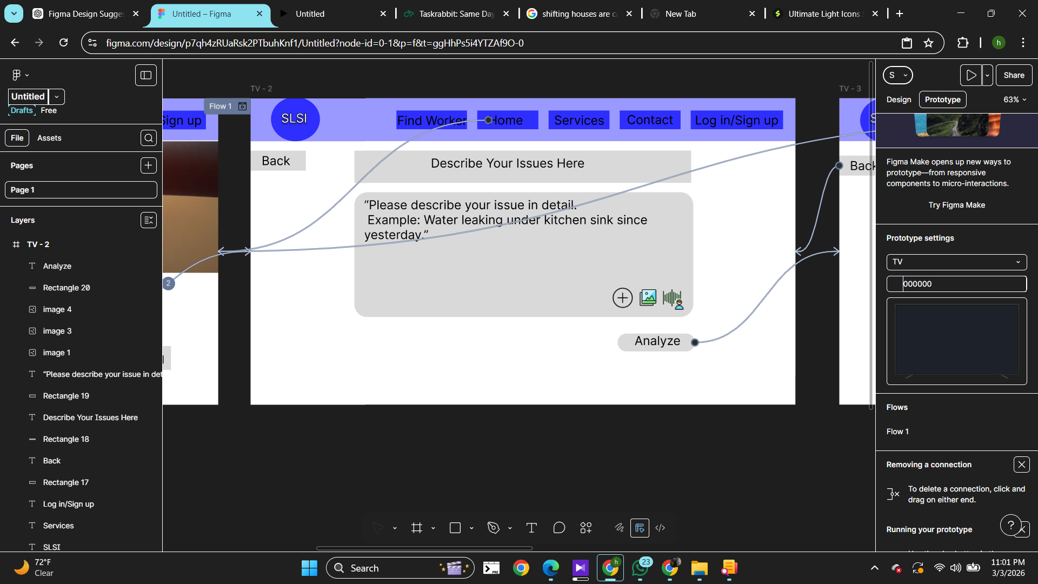

Feature- 02:Auto Categorization

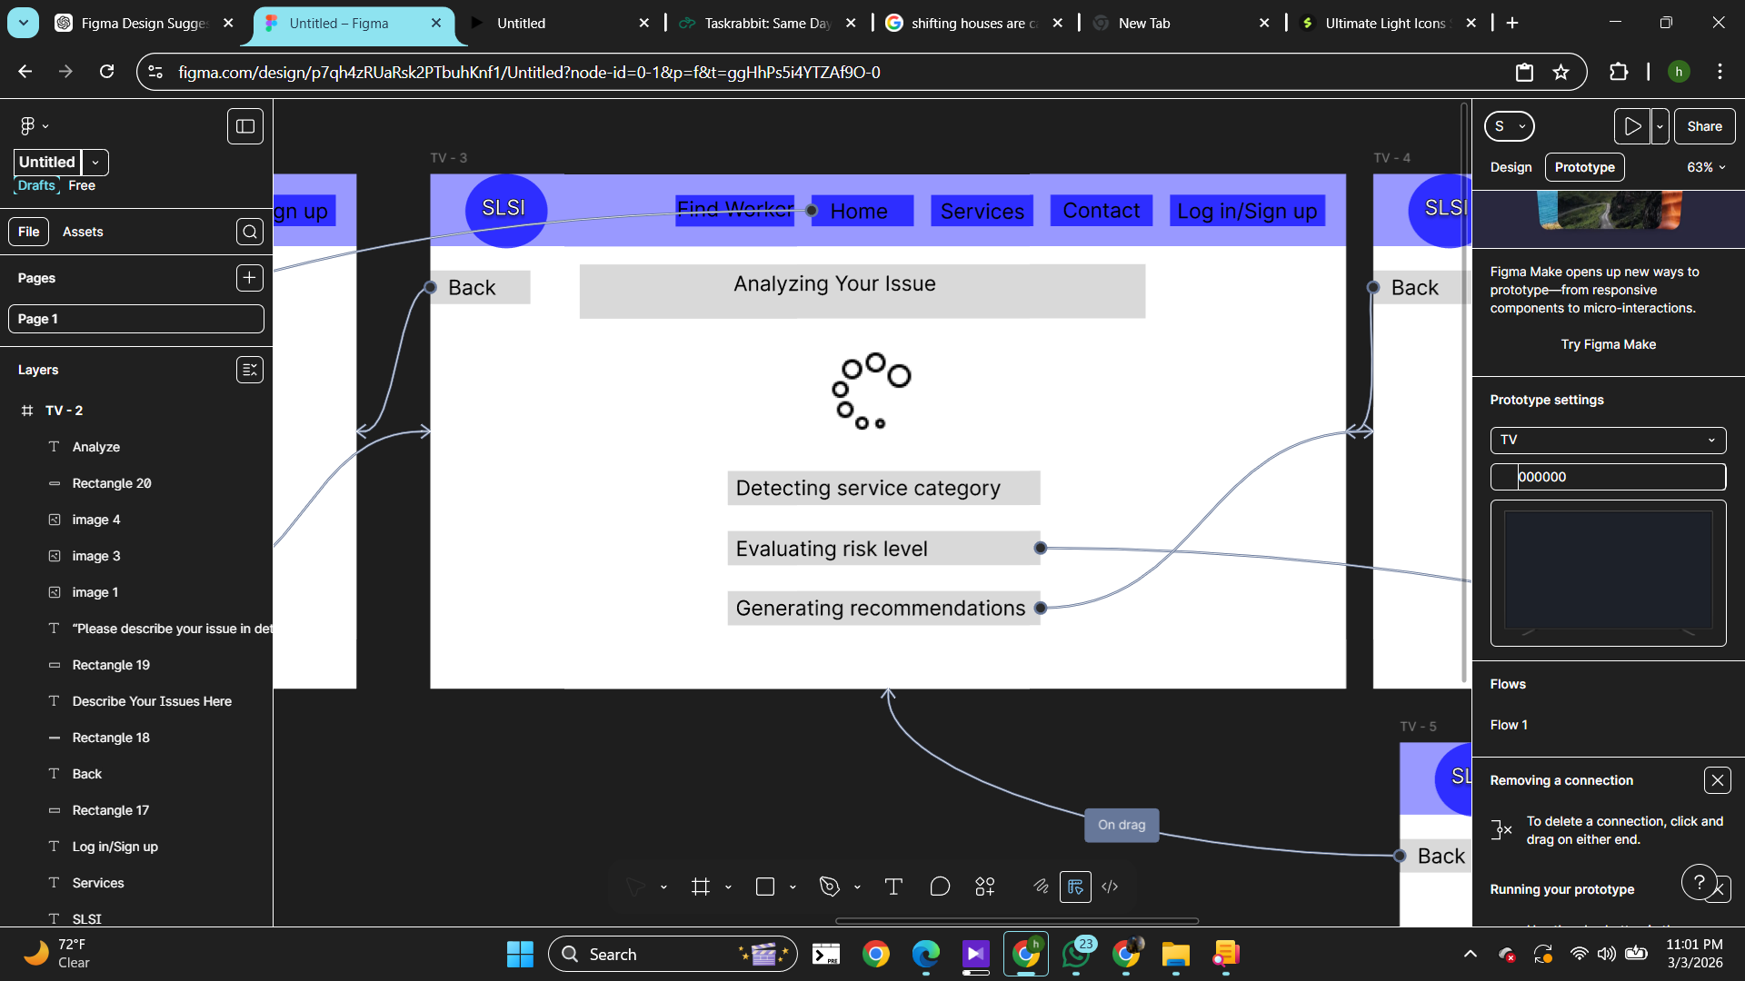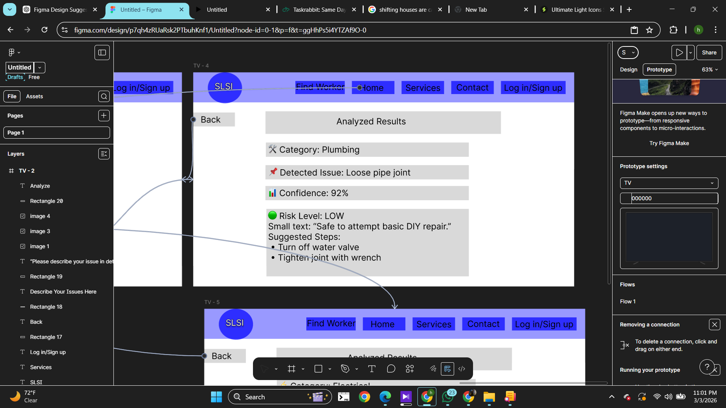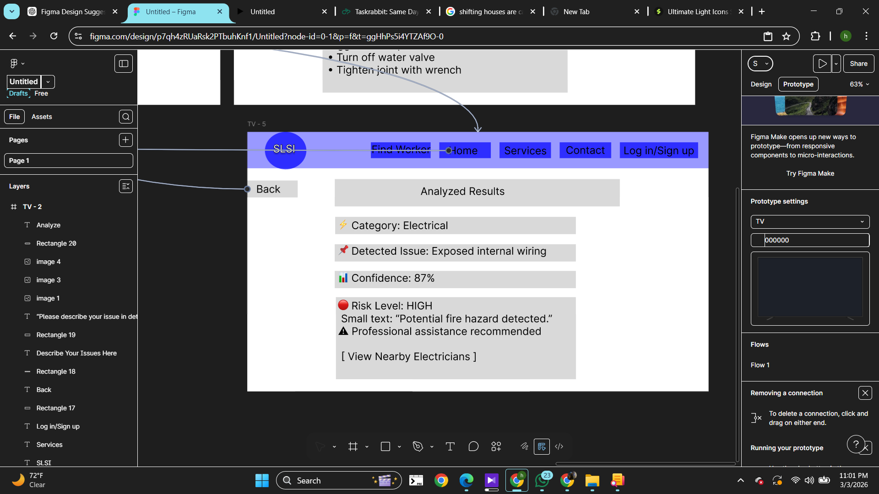

Figma File Link

https://www.figma.com/design/p7qh4zRUaRsk2PTbuhKnf1/Untitled?node-id=0-1&t=tB1qKu6O7kVmJnSk-1

Prototype Link
https://www.figma.com/proto/p7qh4zRUaRsk2PTbuhKnf1/Untitled?node-id=0-1&t=tB1qKu6O7kVmJnSk-1

